1. **PURPOSE**

The purpose of this procedure is to define the requirements for managing Unique Device Identification (UDI) used by GT Medical. (hereinafter “GT Medical”) in the production of GT Medical products.

GT Medical product labeling is managed by the contract manufacturer, and mutually approved in accordance with the provisions of the Quality Assurance Agreement.

1. **SCOPE**

This procedure applies to all devices including those used clinical investigations.

Due to the low anticipated number of DI records to submit, this procedure only applies to the manual data entry into the GUDID. Therefore, the HL7 SPL method is not covered in this procedure.

1. **REFERENCES**

* 21 CFR 820.120 Device Labeling
* 21 CFR 801 Labeling
* 21 CFR 830 Unique Device Identification
* FDA Unique Device Identification System, Final Rule
* F-004A, Labeling Checklist
* F-004B, Device Identifier (DI) Record

1. **DEFINITIONS**
   1. Adulterated: A product is adulterated if it contains a substance which may make the product harmful to consumers under customary conditions of use; if it contains a filthy, putrid, or decomposed substance; if it is manufactured or held under insanitary conditions whereby it may have become contaminated with filth or may have become harmful to consumers; or if it is not a hair dye and it contains a non-permitted color additive.
   2. Automatic identification and data capture (AIDC): means any technology that conveys the unique device identifier or the device identifier of a device in a form that can be entered into an electronic patient record or other computer system via an automated process.
   3. Device package: means a package that contains a fixed quantity of a particular version or model of a device.
   4. Global Unique Device Identification Database (GUDID): means the database that serves as a repository of information to facilitate the identification of medical devices through their distribution and use.
   5. Issuing agency: means an organization accredited by FDA to operate a system for the issuance of unique device identifiers.
   6. Labeling: Labeling is all labels and other written, printed or graphic matter accompanying or attached to the device or its container. This also encompasses the Instructions for Use (IFU).
   7. Labeler: means

* Any person who causes a label to be applied to a device with the intent that the device will be commercially distributed without any intended subsequent replacement or modification of the label; and
* Any person who causes the label of a device to be replaced or modified with the intent that the device will be commercially distributed without any subsequent replacement or modification of the label, except that the addition of the name of, and contact information for, a person who distributes the device, without making any other changes to the label, is not a modification for the purposes of determining whether a person is a labeler.
  1. Misbranded: A product is misbranded if its labeling is false or misleading, if it does not bear the required labeling information, or if the container is made or filled in a deceptive manner.
  2. Unique Device Identification (UDI): means an identifier that adequately identifies a device through its distribution and use. A unique device identifier is composed of:
* A device identifier (DI) -- a mandatory, fixed portion of a UDI that identifies the specific version or model of a device and the labeler of that device; and
* A production identifier (PI) -- a conditional, variable portion of a UDI that identifies one or more of the following when included on the label of the device:
  + The lot or batch within which a device was manufactured;
  + The serial number of a specific device;
  + The expiration date of a specific device;
  + The date a specific device was manufactured.
  1. Version or model: means all devices that have specifications, performance, size, and composition, within limits set by the labeler.

1. **RESPONSIBILITY**
   1. The contract manufacturer is responsible for developing labeling specifications and performing any applicable validations.
   2. GT Medical is responsible for approving labeling developed by the contract manufacturer in accordance with the provisions of the Quality Assurance Agreement.
   3. GT Medical is responsible for submitting DI records to the GUDID.
   4. Regulatory Contact:[1]

* Responsible for GUDID submission requirements
* Will be the primary point of contact for communications from the FDA to your organization
* May be a 3rd party
* Does not have functional user role in GUDID, i.e. no username or password to access GUDID
* Can also serve as GUDID Coordinator and Labeler Data Entry user, if so desired
  1. Coordinator:
* Manages GUDID labeler accounts
* Has a username and password to access GUDID
* May be first contacted by the FDA for issues related to the data submitted to GUDID, and if the issue is not resolved, the FDA will bring it to the attention of the Regulatory Contact
* Responsible for creating the Labeler Data Entry (LDE) accounts
* Can create and edit device records
* May also serve as an LDE user
* A given Labeler DUNS Number can be assigned to more than one Coordinator. The Coordinators would then share responsibility for DI records associated to that Labeler DUNS number.
  1. Labeler Data Entry (LDE) User:
* Submits required information for each device to the GUDID
* Has a username and password to access GUDID

1. **PROCEDURE**
   1. **Creating UDI(s)**
      1. After selecting the most appropriate accredited Issuing Agency (GS1 or HIBCC), the total number of UDI’s needs to be determined. The number of UDI will be determined based on the packaging configuration. All levels of packaging down to the lowest level (patient use/Unit of use) need to bear a UDI, except the shipping containers (e.g. brown corrugate box).
      2. In cases where a device is intended for more than one use and reprocessed before each use, UDI’s must be directly marked on the device.
      3. After registering and create membership with the selected Issuing Agency based on UDI capacity needs for the company, provide Issuing Agency the necessary information to create device barcodes and plain text. Each Issuing Agency has different requirements, refer to Issuing Agency’s requirements.
      4. A device identifier shall be used to identify only one version or model.
   2. **Use of Symbols**
      1. The following information is applicable to the approval of contract manufacturer labels.
      2. Use of symbols from ANY standard produced by a Standards Development Organization even if that standard (or part of the standard containing the symbol) is not formally recognized by FDA is permitted. In the use of non-recognized standards, the symbol is to be used in compliance with the requirements of the source standard, or GT Medical needs to be able to justify any deviations from such requirements.
      3. When symbols are used, the explanations don’t have to appear on labelling next to the symbol, but they may be provided in a separate glossary of symbols, provided either printed glossary in the IFU or as a separate leaflet with the device or as an electronic glossary (e.g. which could mot easily be maintained by publication on a web page with a link printed on the labelling).
   3. **Approving medical device labeling**
      1. GT Medical shall approve contract manufacturer labeling in accordance with the provisions of the Quality Assurance Agreement. If needed, appropriate corrective action(s) shall be taken prior to approval by the contract manufacturer to obtain satisfactory labeling.
      2. Before final approval, labeling will be discussed at appropriate design review meetings.
      3. The following forms will be completed for each new labeling prior to approval:

* F-004A, Labeling Checklist
  + Will be used as a checklist tool prior to approving each labeling
* F-004B, Device Identifier (DI) Record
  + Will be used to submit and maintain the DI record(s) published on the GUDID
  + DI record approval will be provided on this form prior to submitting on the GUDID
    1. The Design History File will be updated, as necessary, to reflect labeling changes. Upon design transfer to production, the final labeling will then be added to (or referenced by) the Device Master Record.
  1. **Preparing and Requesting GUDID Account from FDA**
     1. Before requesting an FDA GUDID account, follow these steps to prepare to submit information to the GUDID:
* Gather data required on F-004B, Device Identifier (DI) Record and obtain approval by a Quality Representative or Executive Management Representative.
* Understand the GUDID account structure and user roles as defined in Section 5 of this procedure and shown in Appendix A.
  + Identify company’s individuals for the GUDID user roles and ensure that they understand GUDID functionality and responsibility for their user role.
* Identify/obtain appropriate Dun and Bradstreet (D&B) (DUNS) numbers
  + If GT Medical has a DUNS number(s), verify that the information in the D&B database is correct and update any information if necessary.
    1. Submit a [GUDID New Account Inquiry](http://www.fda.gov/MedicalDevices/DeviceRegulationandGuidance/UniqueDeviceIdentification/GlobalUDIDatabaseGUDID/ucm416113.htm).
    2. Receive email from UDI Help Desk. This email should contain a PDF file of the GUDID Account Request document
* If you do not receive an immediate reply in your inbox, please check the spam/junk folder. If the email is not in this folder, contact the UDI Help Desk.
  + 1. Complete and attach the GUDID Account Request document in an email reply to the FDA UDI Help Desk.
    2. Upon receipt of this document, an UDI Help Desk Analyst will review your request and respond as soon as possible with your GUDID account login information.
    3. Login to your GUDID in the [web interface](http://www.fda.gov/MedicalDevices/DeviceRegulationandGuidance/UniqueDeviceIdentification/GlobalUDIDatabaseGUDID/ucm416117.htm) website using the account information.
    4. Enter additional registration information prompted for the new GUDID account and set up user roles.
    5. If needed, create and verify login information for GUDID Coordinators and Label Data Entry Users.
    6. To make any changes to your GUDID account, contact the UDI Help Desk.
  1. **Submitting DI records to the GUDID**
     1. Review the [GUDID guidance documents](http://www.fda.gov/MedicalDevices/DeviceRegulationandGuidance/UniqueDeviceIdentification/ChangesbetweenUDIProposedandFinalRules/default.htm) and obtain necessary device information to populate new DI records in the GUDID (see information collected on F-004B, Device Identifier (DI) Record).
     2. Login to your GUDID account and create a new DI record for each device.
     3. Review each DI record and submit for FDA review.
     4. After the DI record passes the FDA review, your DI record is in a published state and can be retrieved by the public.
     5. Conduct a search in the GUDID using your DI information and confirm that your published DI records are retrievable and contain accurate and correct information.
     6. To manage and edit existing DI records, refer to the [GUDID guidance documents](http://www.fda.gov/MedicalDevices/DeviceRegulationandGuidance/UniqueDeviceIdentification/ChangesbetweenUDIProposedandFinalRules/default.htm).
  2. **Modifying labeling**
     1. Any changes to released labels or labeling will be approved by GT Medical in accordance with the Quality Assurance Agreement.
     2. Where applicable, the appropriate section of F-004A, Labeling Checklist will also be completed to determine if the change creates a new version or model, and it should leave a record of the decision-making process and showing the relationship of the prior device identifier to the new device identifier. The DI represents the version or model of the device. If a change modifies the device outside established limits, then a new DI needs to be assigned and a new DI record needs to be created in GUDID.
     3. Whenever a new device package is created, a new device identifier to the new device package must be assigned.
     4. If a new DI needs to be assigned, a F-004B Device Identifier Record will be completed and the new DI record submitted to the GUDID.
     5. Where applicable, create necessary updates in design and production files to reflect the UDI labeling modifications (i.e., Design History Files (DHF), Device Master Records (DMR), Device History Records (DHR), etc.).
     6. Notify the respective regulatory authorities responsible for approval/clearance of your company’s products of the labeling updates as required and deemed necessary.
     7. The contract manufacturer shall be notified of any changes to UDI labeling, by sending a copy of the relevant F-004B Device Identifier Record.
  3. **Obsoleting UDI**
     1. In the event that a version or model of a device is discontinued, its UDI may not be reassigned to another device. If a discontinued version or model is re-introduced and no changes have been made that would require the use of a new device identifier, the UDI that was previously in use may be used to identify the device.
  4. **DI Record Retention**
     1. Since theUDI record retention period is three (3) years from the date the labeler ceases to market the version or model, but the QSR record retention period is a period of time equivalent to the lifetime of the device, but in no case less than 2 years from the date of release for commercial distribution, the labeler shall apply whichever retention time is longer for a minimum of three (3) years.

1. **APPENDIX**
   1. Appendix A – GUDID User Roles
2. **DOCUMENT HISTORY**

|  |  |
| --- | --- |
| Functional Area | Signature & Date |
| Operations |  |
| Quality |  |
| Regulatory |  |

|  |  |  |
| --- | --- | --- |
| **REVISION HISTORY** | | |
| Rev. # | Released Date  (YYYY-MM-DD) | Author |
| 1 | 2018-05-14 | Michelle Lott |
| 2 | 2018-11-26 | Raines DeMint |

**APPENDIX A – GUDID User Roles**

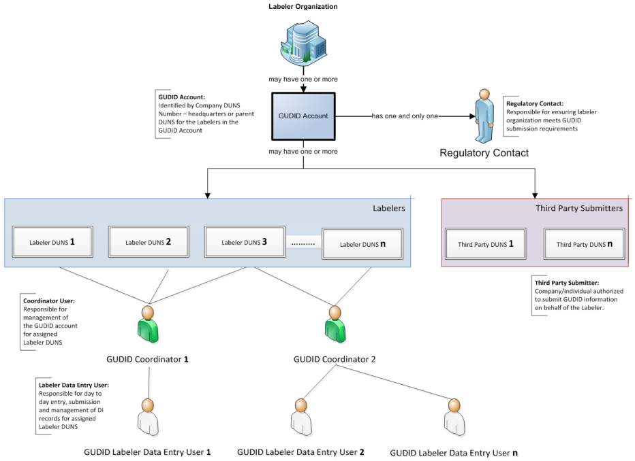

1. To delegate the Regulatory Contact duties to a 3rd party, GT Medical needs to provide, along with the GUDID Account Request, a Letter of Authorization stating:

   for which devices the 3rd party will serve as contact;

   how long the 3rd party will serve as contact; and

   who will notify the FDA in case the 3rd party is modified or removed.